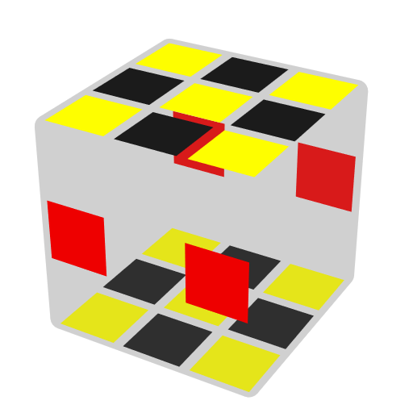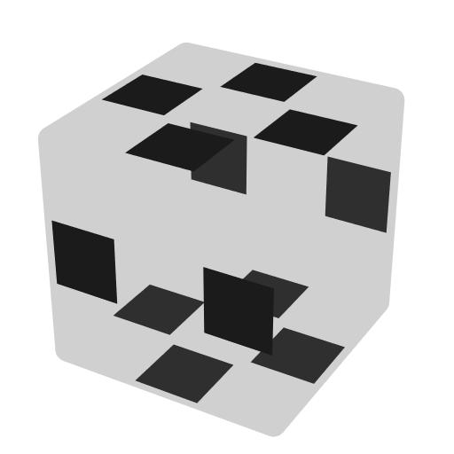**DR Trigger Algorithms**

EO-> DR Trigger ->DR. Ignore L2/R2 setup. Only show some useful cases. Last move of algs can always be replaced by a '. E-edge in U/D, U/D-edge in E, U/D sticker on twisty corner. Learn 4 move 4c4e first.

**Basic Cases**

|  |  |  |  |  |
| --- | --- | --- | --- | --- |
| **3c2e** |  |  |  |  |
|  |  |  |  |  |
| **R U R** | **R U' R** | **R' U' R F2 U R** |  |  |
|  |  |  |  |  |
| **4c2e** |  |  |  |  |
|  |  |  |  |  |
| **R U2 R** / L F2 L | **L' R U R' U' L** | **L' U R U' R' L** | **R U R' U' R U2 R** | **R' F2 D' F2 R** |
|  |  |  |  |  |
| **L F2' L' U R U2 R** |  |  |  |  |
|  |  |  |  |  |
| **4c4e** |  |  |  |  |
| **<5 move** [Complete, 38]Jack Love | | | | |
|  |  |  |  |  |
| **R** | **F2 R** | **F2 U2 R** | **F2 U R** | **L2 U' R** |
|  |  |  |  |  |
| **F2 U' R'** | **R2 U R** | **R2 F2 R** | **R2 U2 R** | **F2 B2 R** |
|  |  |  |  |  |
| **L2 U' D R** | **F2 U2 D2 R** | **F2 U D2 R** | **F2 U2 D R** | **R2 F2 U2 R** |
|  |  |  |  |  |
| **F2 U D R** | **L2 F2 U R** | **F2 L2 U R** | **R2 F2 U R** | **F2 L2 U' R** |
|  |  |  |  |  |
| **R2 F2 U' R** | **F2 R2 U' R** | **L2 F2 U' R** | **F2 R2 U R** | **L2 U2 F2 R** |
|  |  |  |  |  |
| **F2 R2 U2 R** | **R2 U F2 R** | **F2 U' F2 R** | **R2 U' F2 R** | **B2 U F2 R** |
|  |  |  |  |  |
| **L2 U F2 R** | **B2 U' F2 R** | **L2 U' F2 R** | **F2 U F2 R** | **R2 L2 U R** |
|  |  |  |  |  |
| **F2 U2 F2 R** | **R U2 F2 R** | **R' U2 F2 R** |  |  |
|  |  |  |  |  |
| **>4 move** |  |  |  |  |
|  |  |  |  |  |
| **L U' F2 U' D' L** | **L' U R U' L** | **L' U L R U' R** | **R' F2 R2 U2 R** | **R' D' F2 D R** |
|  |  |  |  |  |
| **2c2e** |  |  |  |  |
|  |  |  |  |  |
| **L U' R U L' U R** | **L' U2 R U R' U2 L** | **L' U2 R U2' R' U2 L**  B' U R U' R' U' B | **L R U' R' U L** | **R' U' F2 U R** |
|  |  |  |  |  |
| **R' D F2 D' R** | **R U' R2 D R** | **R' D R2 U' R'** | **R' U F2 U2 R2 D R'** |  |
|  |  |  |  |  |
| **2c** |  |  |  | **3c** |
|  |  |  |  |  |
| **U L' U R2 U' L** | **U R' D L2 D' R** | **R U' R2 D R2 U R**  R2 D' R' U L2 U' R | **R D L2 D' R**  R D r2' U' R | **R U'D R' UD' R** |
|  |  |  |  |  |
| **4c** |  | **2e** |  |  |
|  |  |  |  |  |
| **R' U' F2 U F2 R** | **R U' R' U2 R U' R** | **R F2 U2' F2 R** |  |  |
| **2c4e** | **4c6e** | **5c4e** |  |  |
|  |  |  |  |  |
| **R' D' R L' U L** | **R U2 L** | **R F2 U R** |  |  |
|  |  |  |  |  |
| **All 5 move R,U-gen Cases**  Robert Yau | | | | |
| **2c1e** |  |  |  |  |
|  |  |  |  |  |
| **R' U2 R' U2 R** | **R' U2 R U2 R** | **R U2 R' U2 R** | **R U2 R U2 R** |  |
|  |  |  |  |  |
| **3c2e** |  |  |  |  |
|  |  |  |  |  |
| **R' U' R' U R** | **R' U' R U R** | **R' U R' U' R** | **R' U R U' R** | **R U' R' U R** |
|  |  |  |  |  |
| **R U' R U R** | **R U R' U' R** | **R U R U' R** |  |  |
|  |  |  |  |  |
| **3c4e** |  |  |  |  |
|  |  |  |  |  |
| **R' U' R' U' R** | **R' U R U R** | **R U' R' U' R** | **R U R U R** |  |
|  |  |  |  |  |
| **4c2e** |  |  |  |  |
|  |  |  |  |  |
| **R' U' R2 U R** | **R' U R2 U' R** | **R' U2 R2 U2 R** | **R U' R2 U R** | **R U R2 U' R** |
|  |  |  |  |  |
| **R U2 R2 U2 R** |  |  |  |  |
|  |  |  |  |  |
| **4c4e** |  |  |  |  |
|  |  |  |  |  |
| **R' U' R' U2 R** | **R' U R U2 R** | **R' U2 R' U' R** | **R' U2 R U R** | **R U' R' U2 R** |
|  |  |  |  |  |
| **R U R U2 R** | **R U2 R' U' R** | **R U2 R U R** |  |  |
|  |  |  |  |  |
| **5c4e** |  |  |  |  |
|  |  |  |  |  |
| **R' U' R U2 R** | **R' U R' U2 R** | **R' U2 R' U R** | **R' U2 R U' R** | **R U' R U2 R** |
|  |  |  |  |  |
| **R U R' U2 R** | **R U2 R' U R** | **R U2 R U' R** |  |  |
|  |  |  |  |  |
| **6c4e** |  |  |  |  |
|  |  |  |  |  |
| **R' U' R2 U' R** | **R' U R2 U R** | **R U' R2 U' R** | **R U R2 U R** |  |
|  |  |  |  |  |
| **3c3c4e** |  |  |  |  |
|  |  |  |  |  |
| **R' U' R U' R** | **R' U' R2 U2 R** | **R' U R' U R** | **R' U R2 U2 R** | **R' U2 R2 U' R** |
|  |  |  |  |  |
| **R' U2 R2 U R** | **R U' R U' R** | **R U' R2 U2 R** | **R U R' U R** | **R U R2 U2 R** |
|  |  |  |  |  |
| **R U2 R2 U' R** | **R U2 R2 U R** |  |  |  |